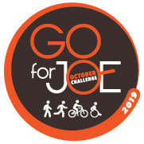
Track your Progress 2020
Participant Name:
Goal:
Thank-you for agreeing to be a “Go for JOE” Participant. To help keep track of your progress both in terms of time/distance spent walking, running, or riding and for donations which have been raised, please use the following form. You can track your kilometers or time (or both).
Date: October | Number of Kilometers you Walked/Ran or Rode | Amount of time you Walked/Ran or Rode | Money raised
Week 1
Week 2
Week 3
Week 4
Grand Total

Sponsor Name | Sponsor Amount

